MINISTRY OF EDUCATION AND SCIENCE OF UKRAINE

NATIONAL TECHNICAL UNIVERSITY   
“KHARKIV POLYTECHNIC INSTITUTE”

Department of Software Engineering and Management Information Technology

REPORT

on laboratory work # 5

on the discipline

“python frameworks”

Executed by

Student of the group KN-218g.e

Karyna OHOL

Checked by

Ass. Prof. of department “SEMIT”

Svitlana KOVALENKO

Kharkiv 2020

DataFrames Merging, Data Aggregation and Data Visualization

**Objectives**

**Goal**: Learning advanced Pandas features for data analysis.

**Tasks**

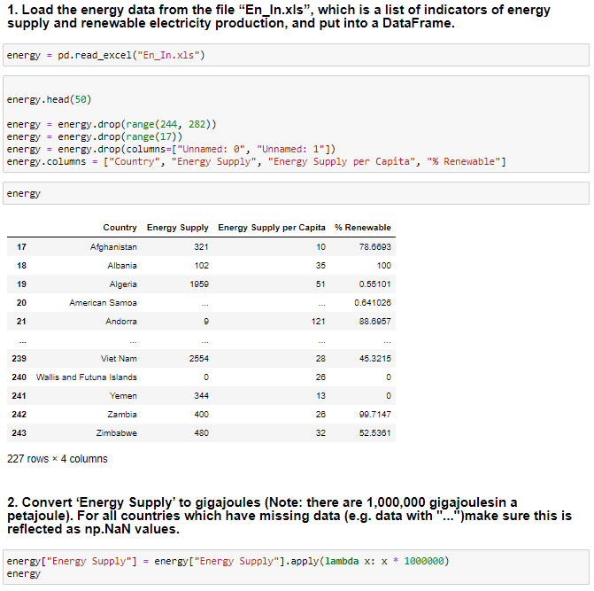

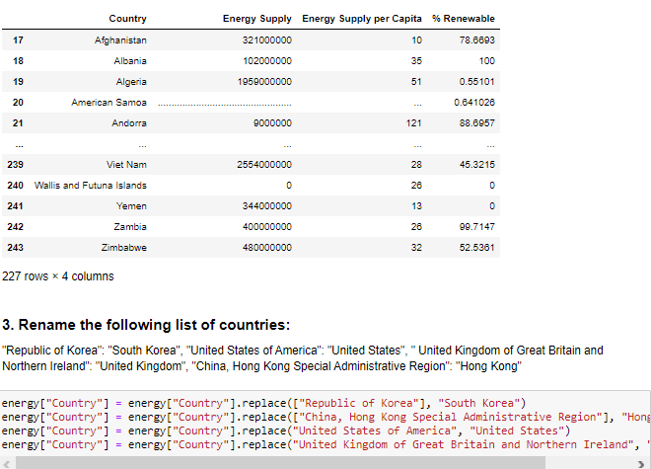

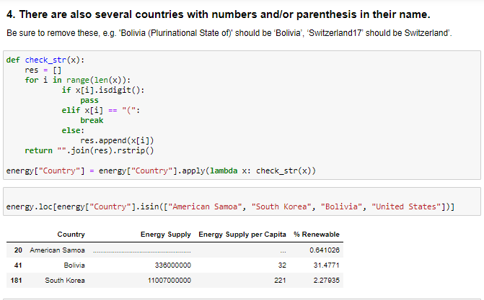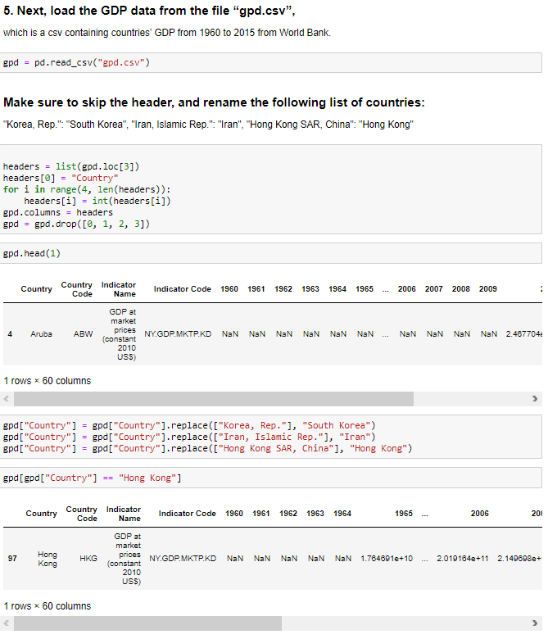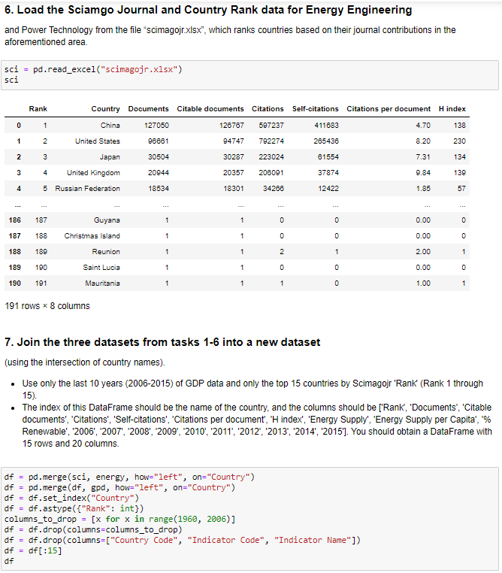

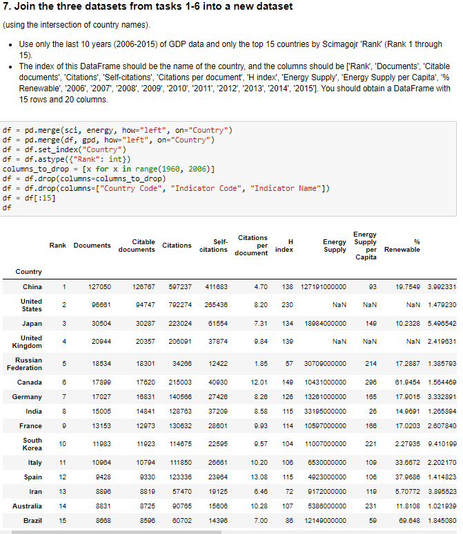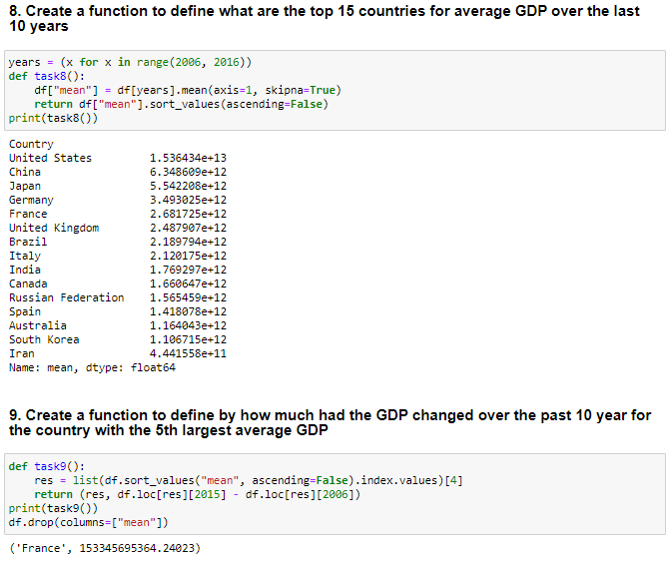

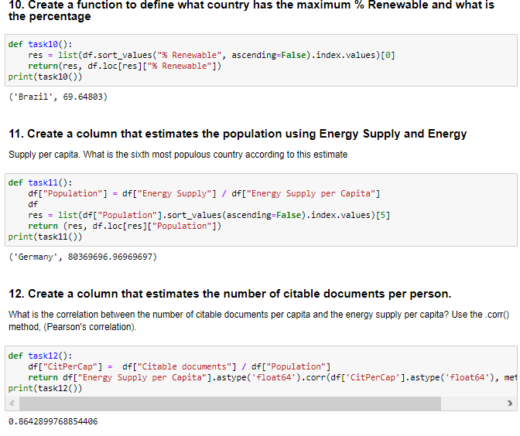

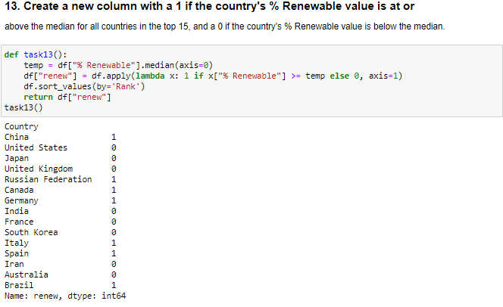

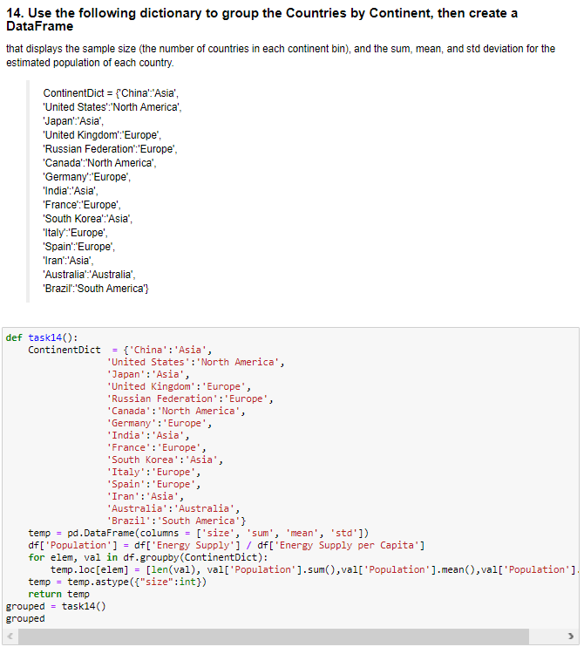

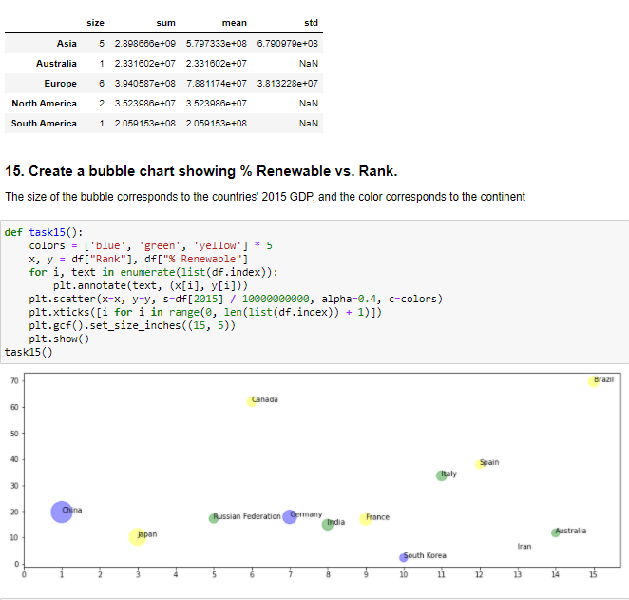

**Conclusions**

To conclude, during today’s laboratory training some possibilities to create and modify data using pandas library were discovered and tested. Moreover, some pyplot features were also revised.